
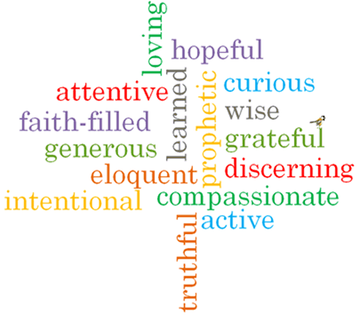
Topic: Healing
Strand: Reconciliation

Phase: UKS2
Come and See Knowledge Organiser
What should I already know?
God’s rules for living freely and responsibly – the commandments.
Big Questions
Why do we care for the sick?
Why do people give time and commitment for caring for others?
What gives a person comfort when they are very ill?
Vocabulary I will need to use
Care | The provision of what is necessary for the health, welfare & maintenance and protection of someone or something.
Sickness | The state of being ill.
Hospice | A home providing care for the sick or terminally ill.
Compassion | Sympathetic, pity & concern for the sufferings or misfortunes of others.
Sacrament | A religious ceremony or ritual regarded as imparting divine grace.
Anointing | To smear or rub with oil, typically as part of a religious ceremony.
sin | An immoral act considered to be a transgression against divine law.
forgiveness | The action or process of forgiving or being forgiven.
parable | A simple story used to illustrate a moral or spiritual lesson, as told by Jesus in the Gospels.
Lourdes | A town in South West France, a place of pilgrimage for Roman Catholics as the site of an apparition of the Virgin Mary.
Responsibility | The state or fact of having a duty to deal with something or of having control over someone.

What I will learn?
Make links to show how feelings and beliefs about sickness and care affects their behaviour and that of others. Compare their own and other people’s ideas about questions concerning serious illness and bereavement. Use a developing religious vocabulary to give reasons for the religious actions and symbols used in the Sacrament of the Anointing of the Sick. Give reasons why Christians care for the sick and the needy.
Engage and respond to questions of the experience of sickness and healing in the light of religious teaching. Show how their own and others’ decisions about care and compassion towards the sick are informed by beliefs and values. Describe and show understanding of religious sources, beliefs, ideas, feelings and experiences concerning the Sacrament of the Anointing of the Sick and make links between them. Use religious terms to show an understanding of the different liturgies connected to the sacraments offered to the sick and dying. Show understanding of how religious belief shapes life, and that caring for those in need is a Christian responsibility.

Virtues

Scripture I will hear:
Mark 6: 13
Luke 18: 35-43
Luke 10: 30-37
James 5: 14-15

