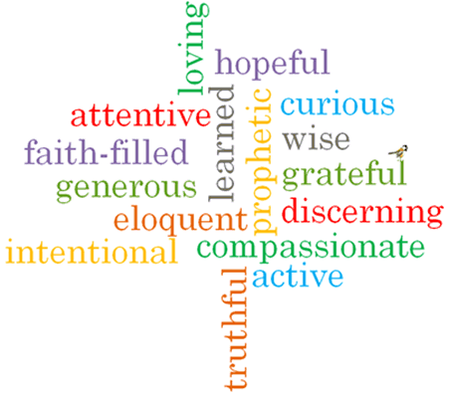

Topic: Death & New Life
Strand: Lent/Easter

Phase: UKS2
Come and See Knowledge Organiser
What should I already know?
Lent is a time of giving in preparation for the celebration of the sacrifice of Jesus.
Big Questions
Why does loss and death bring about change?
How do people cope with loss and death?
Vocabulary I will need to use
Loss | The fact or process of losing something or someone.
Death | the action or fact of dying or being killed; the end of the life of a person or organism.
Change | Make or become different.
Growth | The process of increasing in size.
Ash Wednesday | The first day of Lent marked by services of penitence.
Lent | The period preceding Easter, which is devoted to fasting, abstinence, penitence and alms giving.
Holy Week | The week before Easter, beginning on Palm Sunday.
The Triduum | A period of 2 days observance – Maundy Thursday, Good Friday & Holy Saturday.
Easter Vigil | The ceremonies of Holy Saturday & the ost solemn memorial of the liturgical year. Consists of four parts; the service of light, Liturgy of the Word, Liturgy of Baptism and Liturgy of the Eucharist.
Resurrection | The rising of Christ from the dead.

What I will learn?

Make links to show how feelings and beliefs about loss and death affect their behaviour and that of others.
Compare their own and other people’s ideas about questions concerning loss and death which are difficult to answer.
Make links between Scripture and belief in the Resurrection of Jesus.
Use a developing vocabulary to give reasons for religious actions and symbols connected with Lent, Holy Week and the Sacred Paschal Triduum.
Give reasons for certain actions by believers during Lent.
Show how their own and others’ decisions concerning the effects of death and loss are informed by beliefs and values.
Describe and show understanding of religious sources, beliefs, ideas, feelings and experiences connected with Lent, Good Friday of the Passion of the Lord; and The Easter Vigil in the Holy Night; making links between them.
Use a variety of religious terms accurately to show an understanding of the different liturgies of Ash Wednesday, Lent, Good Friday of the Passion of the Lord; and The Easter Vigil in the Holy Night.
Show understanding of how religious belief in death and new life shapes life.
Engage with and respond to questions about death and new life in the light of religious teaching.

Virtues

Scripture I will hear:
John 6: 35, 37,51, 60,67-68
John 11: 1-43
John 12: 24-25
John 19: 16-21, 25-30, 38-42
John 20: 1-8

