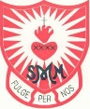
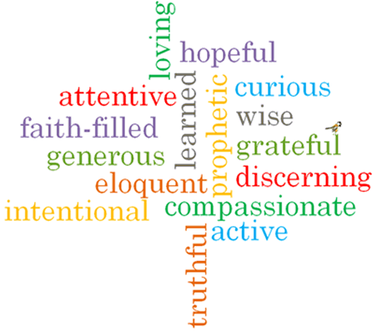
Topic: Sources
Strand: Local Church

Phase: UKS2
Come and See Knowledge Organiser
What should I already know?
Dioceses continue the work and mission of Jesus, including ecumenism.
Big Questions
How our lives are enriched by books?
The wonder of books and how they take a person beyond themselves
Vocabulary I will need to use
Poetry | Written work in which the expression of feelings & ideas is given intensity by the use of distinctive style & rhythm.
Prose | Written or spoken language in its ordinary form.
History | The study of past events.
Information | Facts provided or learned about something or someone.
Stories | An account of imaginary or real people and events told for entertainment.
Bible | Christian scriptures.
Old Testament | The first part of the Christian Bible, comprising 39 books of the chief texts of law, history, prophecy & wisdom literature of the ancient people of Israel.
New Testament | The second part of the Christian Bible, recording the life & teachings of Jesus Christ and his earliest followers. It includes the four Gospels.
genre | A style or category of art, music or literature.

What I will learn
Compare their own and other people’s ideas about how books enrich our lives and take us beyond ourselves.
Make links between scripture and Christian beliefs.
Give reasons for when and how Christians use the Bible.
Describe and show an understanding of the Bible, the beliefs, ideas, feelings and experiences of the Christian and make links between them.
Show understanding of how the Bible shapes the lives of Christians.
Engage with the question, ‘What is God like?’ or ‘What is Jesus like?’ in the light of religious teaching.
Show how their own and others’ decisions are informed by beliefs and values which may be influenced by what they have read.

Virtues

Scripture I will hear:
Romans 15: 4-6
Bible
Bible references, genre, context

