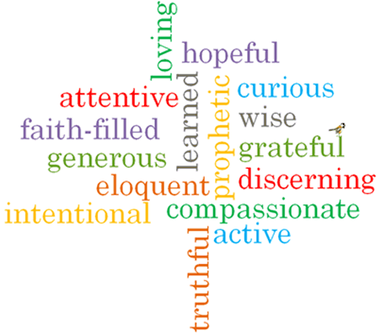
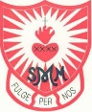
Topic: Vocation & Commitment
Strand: Baptism/Confirmation

Phase: UKS2
Come and See Knowledge Organiser
What should I already know?
The call to life and love within the community and the sacrament of marriage.
Big Questions
What does it mean to be committed?
Why are some people so dedicated to the service of others?

Vocabulary I will need to use
commitment | Dedication to something.
dedicated | Devoted to a task or purpose.
vocation | A strong feeling of suitability for a particular career.
Ordination | The action of ordaining someone in Holy orders.
anointing | To smear or rub with oil as part of a religious ceremony.
Religious life | A state of life in the Catholic Church, lived by believers who wish to follow Jesus Christ in a more exacting way.
service | The action of helping or doing work for someone.
celibacy | The state of abstaining from marriage or relations with another person.
vows | a solemn promise

What I will learn

Make links to show how feelings and beliefs affect behaviour in relation to commitment.
Using a developing religious vocabulary, to give reasons for the signs and symbols used in the Sacrament of Holy Orders.
Give reasons why Christians fulfil their baptismal promises by answering God’s call through their chosen vocation in various ways, including the religious life.
Compare their own and other people’s ideas concerning the questions raised about what it means to be committed.
Compare their own and other people’s ideas concerning why some people are very committed to service of others.
Show how their own and others’ commitment to service and care of others are influenced by beliefs and values.
usU religious terms to show an understanding of prayers of consecration and vows made at ordination and profession.
Show an understanding of how religious belief shapes the lives of Christians in a variety of ways through their chosen vocation.
Some children will be able to engage and respond to questions of life in the light of religious teaching.

Virtues

Scripture I will hear:
Mark 1: 9-11
John 1: 35-41
Matthew 6:19-21

