
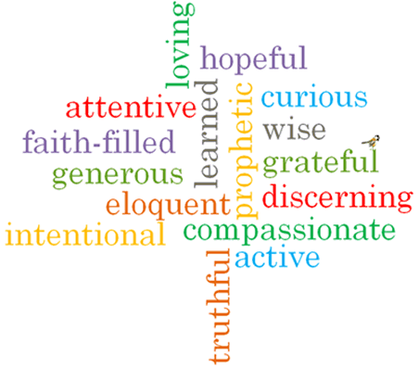
Topic: Unity
Strand: Eucharist

Phase: UKS2
Come and See Knowledge Organiser
What should I already know?
The Eucharist keeps the memory of Jesus’ sacrifice alive and present in a special way.
Big Questions
What helps friendships to grow?
What makes unity between people?
What undermines friendship and unity?
Vocabulary I will need to use
Eucharist | The Christian sacrament commemorating the Last Supper, in which bread and wine are consecrated and consumed.
Communion | The service of Christian worship at which bread and wine are consecrated and shared.
Community | A group f people living in the same place or having a particular characteristic in common.
Unity | The state of being united or joined as a whole.
Friendship | The emotions or conduct of friends; the state of being friends.
nourish | Provide with the food or other substances necessary for growth, health and good condition.

What I will learn?

Make links to show how feelings and beliefs about what makes, and breaks friendship and unity affects their behaviour and that of others.
Ask and respond to questions about their own and others’ experiences and feelings about friendship and unity.
Compare their own and other people’s ideas about questions concerning friendship.
Make links between scripture and the Eucharist.
Use a developing religious vocabulary to give reasons for the actions and symbols of the Communion Rite.
Give reasons why Christians gather together in ‘communion’ and receive ‘Holy Communion’.
Show how their own and others’ decisions about friendships are informed by beliefs and values.
Show understanding of the links between a range of Scripture texts and some parts of the Mass which express communion with Jesus and the feelings that communion with others brings.
Use religious terms to show an understanding of different aspects of the Eucharist.
Show understanding of how belief in Jesus Christ, the uniting presence in Holy Communion, shapes the lives of Christians.

Virtues

Scripture I will hear:
Matthew 6: 9-15
John 17: 11, 20-23
Romans 12: 3-10
1 Corinthians 10:17
1 Corinthians 12:12-13

