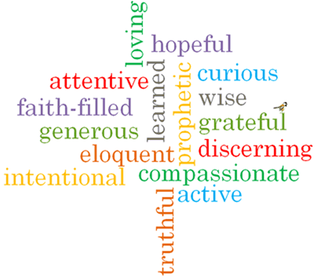

Topic: Witnesses
Strand: Pentecost

Phase: UKS2
Come and See Knowledge Organiser
What should I already know?
Pentecost is the celebration of the Spirit’s transforming power.
Big Questions
Why does it sometimes need courage to be a witness?
How do you know when to speak out?
Vocabulary I will need to use
Witness | A person who sees an event take place.
Holy Spirit | The third person of the Trinity; God as spiritually active in the world.
Martyrs | A person who is killed because of their religious or other beliefs.
Courage | the ability to do something that frightens one; bravery.
Truth | the quality or state of being true.
Inspiration | The process of being mentally stimulated to do or feel something, especially to do something creative.
Good News | The message of Jesus concerning the salvation of the faithful.

What I will learn?

Make links to show how feelings and beliefs affect their behaviour and that of others when it comes to making a decision about being a witness.
Compare their own and other people’s ideas about questions that are difficult to answer about having the courage to witness.
Make links between Scripture and belief in the power of the Holy Spirit.
Give reasons for the witness to Jesus Christ by believers.
Show how their own and others’ decisions about witnessing are informed by beliefs and values.
Show how understanding of belief in the power of the Holy Spirit shapes lives.
Describe and show understanding of Scripture, beliefs, ideas, feelings and experiences of the power of the Holy Spirit in witnessing to the Good News of Jesus Christ and make links between them.

Virtues

Scripture I will hear:
Luke 24: 44-49
Matthew 28: 16-20
Acts 1: 6-14
Acts 6: 6 – 7:
Acts 16: 11-15
Ephesians 2: 10

