
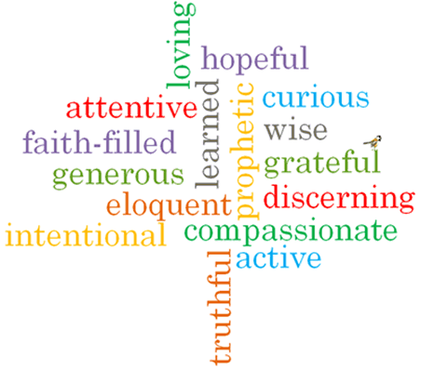
Topic: Expectations
Strand: Advent/Christmas

Phase: UKS2
Come and See Knowledge Organiser
What should I already know?
Advent is the Church’s season of waiting in joyful hope for the coming of Jesus, the Promised One, at Christmas and at the end of time.
Big Questions
What is the difference between I wish for and I expect?
Why is it good to have high expectations of yourself and others?
What is the role of patience in expectations?
Vocabulary I will need to use
expectation | A strong belief that something will happen or be the case.
certainty | Firm conviction that something is the case.
Advent | A season in the Church’s year. A time of waiting in joyful hope..
Christmas | A Christian festival celebrating Jesus Christ’s birth.
Emmanuel | A Hebrew word meaning “God is with us”.
Annunciation | The announcement by the Angel Gabriel to Mary that she would be the mother of God’s son, Jesus Christ.
Angelus | A prayer of the Catholic Church devoted to Jesus being God’s representative on Earth. The prayer includes the Hail Mary and is traditionally said at morning, noon and sunset.
Incarnation | How Jesus Christ embodies God in the flesh on Earth.

What I will learn

Make links to show how feelings and beliefs about expectations affect their behaviour and that of others.
Compare their own and other peoples’ ideas about questions about expectation that are difficult to answer.
Make links between scripture of religious belief in Advent as a time of joyful expectation.
Give reasons for certain actions by believers as they wait in joyful expectation of Advent and Christmas.
Show an understanding of how their own and others’ decisions concerning expectations are informed by beliefs and values.
Engage with and respond to questions about expectation in the light of religious teaching.
Describe and show understanding of religious sources, beliefs, ideas, feelings and experiences of Advent as a time of joyful expectation of Christmas making links between them.
Show understanding of how religious belief in Advent as a time of joyful expectation shapes lives.

Virtues

Scripture I will hear:
John 1: 14-18
Mark 1: 1-5
Isaiah 35: 1-6, 9, 10
Isaiah 62: 11-12
1 Corinthians 1: 8-9, 1 Corinthians 16: 22
1 Corinthians 16: 13-14

