
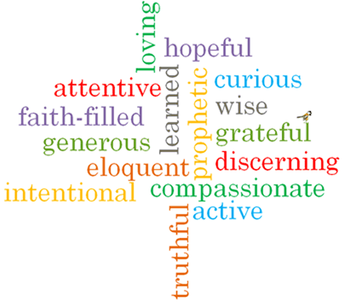
Strand: Domestic Church

Phase: UKS2
Topic: Loving
Come and See Knowledge Organiser
What should I already know?
That we are made in the image and likeness of God.
Big Questions
Does love last forever or does it have limits?
Do you have to earn love?
How can I love people I don’t like?
Vocabulary I will need to use
unconditional | No conditions are attached
Forgiveness | The action or process of forgiving or being forgiven.
Mercy | Compassion or forgiveness shown towards someone.
Prodigal | A person who spends money in a reckless way.
Parable | A story with a meaning used by Jesus to teach.
reconciliation | To forgive and repair a relationship.

Scripture I will hear:
Isaiah 40: 1-5,9-11,28-31
Psalms 23 and 136
Luke 15: 11-32
Matthew 5: 1-12, 44-48
John 15: 9-14
Ephesians 4:26, 31-32
Titus 3: 4-8
What I will learn
Make links between their beliefs about love, their behaviour and how it affects others.
Compare their own and other people’s ideas about questions of unconditional love.
Make links between the story of the prodigal son and the Christian’s belief in God’s forgiveness.
Give reasons for a Christian’s love and care.
Describe and show understanding of the scripture, beliefs, feelings and experience of God’s unconditional love and make links between them.
Show understanding of how religious belief in God’s unconditional love shapes life.
Show understanding of how beliefs and values affect our love and care of each other.
Engage with and respond to questions about loving, in the light of religious teaching.

Virtues

