
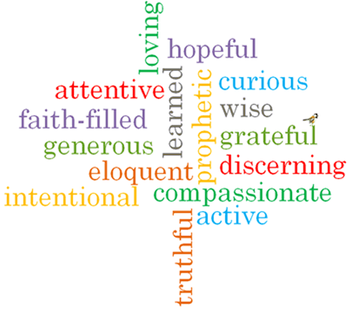
Topic: Transformation
Strand: Pentecost

Phase: UKS2
Come and See Knowledge Organiser
What should I already know?
The new life of the Easter message is spread through the power of the Holy Spirit
Big Questions
How can I transform my energy for the good of others?
How energy can transform?
Vocabulary I will need to use
Transformation
transform
energy,
wind,
fire
Holy Spirit
change,
gift
Fruits of the Spirit

Scripture I will hear:
Galatians : 5: 16-17, 22-23
Luke 24: 13-35
Acts 2: 32-39, 41-42
Acts 22: 6-16
Romans 8: 14-17
What I will learn
Make links to show how feelings and beliefs about the use of transforming energy affects their behaviour and that of others.
Compare their own and other people’s ideas about questions that are difficult to answer about transforming energy and its uses.
Give reasons for the actions of Cleopas on the road to Emmaus.
Use a developing religious vocabulary to give reasons for religious actions and symbols connected with Pentecost.
Give reasons for certain actions of Christians inspired by the Holy Spirit.
Make links between scripture and God’s gift of the Holy Spirit and forgiveness.
Show understanding of how their own and others’ decisions about the use of transforming energy are informed by belief and values.
Describe and show understanding of religious sources, beliefs, ideas, feelings and experiences, concerning the conversation of Paul, making links between them.
Show understanding of the transforming power of the Holy Spirit and how it shapes the lives of Christians.
Engage with and respond to questions about how the belief in the transforming power of the Spirit and the message expressed in Paul’s letter give meaning and purpose to life.

Virtues

