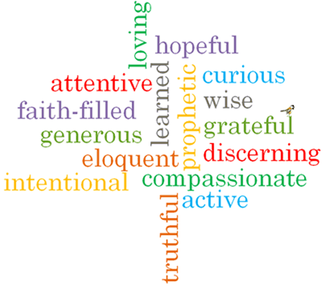
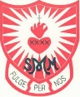
Topic: Stewardship
Strand: Universal Church

Phase: UKS2
Come and See Knowledge Organiser
What should I already know?

Big Questions

Vocabulary I will need to use

Scripture I will hear:

What I will learn

Virtues

