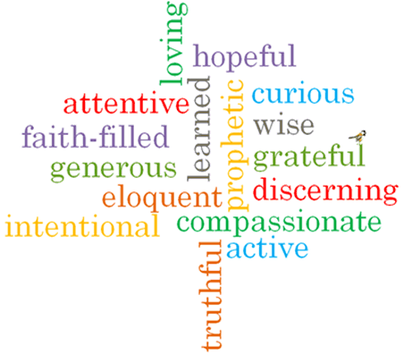

Topic: Memorial Sacrifice
Strand: Eucharist

Phase: UKS2
Come and See Knowledge Organiser
What should I already know?
The Eucharist challenges and enables living and growing in communion
Big Questions
Why do some things evoke memories?
Why are memories important?
How is it possible to keep important memories alive?
Vocabulary I will need to use
Memories | something remembered from the past
Passover | major Jewish festival which celebrates the liberation of the Israelites from Egyptian slavery
Host | a portion of bread used for Holy Communion in many Christian churches
Chalice | the wine goblet used in the Christian Eucharist
Consecration | the action of declaring bread and wine to be, or represent, the body and blood of Christ
Genuflect | bending one knee to the ground, typically in worship
significant
memorial sacrifice
Pesach
liturgy of the Eucharist
Eucharistic Prayer
adoration
acclamation

Scripture I will hear:
Exodus 13: 3
Luke 22: 14-20
What I will learn
Compare their own and others’ ideas about what makes a particular memory significant and why words, symbols or actions might evoke it and realise these questions are difficult to answer.
Make links to show how feelings and beliefs about memories affect their own behaviour and that of others.
Make links between the Passover in Exodus, the Last Supper and belief in the Eucharist.
Use a developing religious vocabulary to give reasons for religious actions and symbols connected to the Passover and the celebration of the Eucharist.
Give reasons for why believers follow the example of Jesus in his life of sacrifice.
Show understanding of how their own and others’ decisions about memories are informed by beliefs and values.
Describe and show understanding of scripture, beliefs, ideas, feelings and experiences about the Jewish Passover, the Last Supper and the celebration of Eucharist, making links between them.
Show understanding of how belief in the sacrifice of Jesus shapes the lives of Christians.
Engage with and respond to questions of life choices in the light of religious teaching about sacrifice.

Virtues

