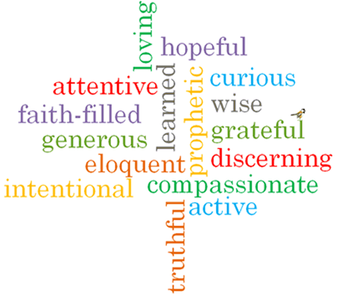

Strand: Baptism/Confirmation

Phase: UKS2
Topic: Life Choices
Come and See Knowledge Organiser
What should I already know?
Confirmation: a call to witness
Big Questions
What is important for friendship to thrive?
Why are fidelity and commitment important in relationships?
Vocabulary I will need to use
Vocation | a strong feeling of suitability for a particular career or occupation.
Marriage | the legally or formally recognized union of two people as partners in a personal relationship
Service | the action of helping or doing work for someone.
Responsibility | the state or fact of having a duty to deal with something or of having control over someone.
Fidelity | faithfulness to a person, cause, or belief, demonstrated by continuing loyalty and support.
Commitment | the state or quality of being dedicated to a cause, activity, etc

Scripture I will hear:
Ephesians 4: 1-7
Ephesians 4: 11-13, 15
Proverbs 31: 10-29
Matthew 5: 6-9
What I will learn
Make links to show how feelings and beliefs affect their own and others’ quality of care and commitment towards each other.
Make links to show how feelings and beliefs affect their own and others’ behaviour in relationships.
Use a developing religious vocabulary to give reasons for the religious actions and symbols used in the Sacrament of Marriage.
Give reasons for the love and service shown by Christians.
Make links to show how feelings and beliefs affect their behaviour and that of others, concerning their mission in life.
Begin to compare their own and other people’s ideas about questions concerning care and commitment that are difficult to answer.
Begin to engage with and respond to questions of life, particularly in relationships.
Begin to describe and show understanding of religious sources, beliefs, ideas, feelings and experiences making links between them; concerning the mission of a Christian and married people in particular.
Use religious terms to begin to show an understanding of the marriage liturgy and the Promises made.
Begin to show understanding of how religious belief shapes the lives of married people.
Begin to show understanding of how religious belief shapes the lives of those who are involved in the community as volunteers.

Virtues

