
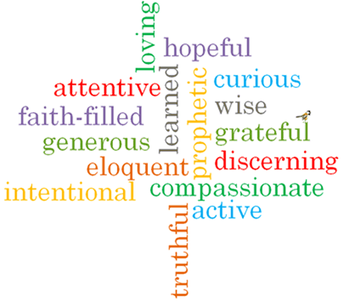
Topic: Sacrifice
Strand: Lent/Easter

Phase: UKS2
Come and See Knowledge Organiser
What should I already know?
Celebrating growth to new life
Big Questions
Why are some people so generous in their giving?
What does sacrifice mean in daily life?
Why do we sometimes refuse to give?
Vocabulary I will need to use
Giving | freely set aside or devote for a purpose
Temptation | the desire to do something, especially something wrong or unwise
Betrayal | the action of betraying a group, or person
Self-sacrifice | the giving up of ones own interests or wishes, in order to help others or advance a cause
Gethsemane | the garden outside of Jerusalem mentioned in Mark 14 as the scene of the agony and arrest of Jesus
Crucifixion | the death of Jesus upon the cross
Resurrection | the act of rising from the dead
carer
cost
Holy Week
Maundy Thursday
Altar of Repose
love
Easter vigil

Scripture I will hear:
Matthew 26: 14-16, 25, 38-48, 47-50
Matthew 28: 1-10
Mark 14: 10-11, 32-36, 43-46
Mark 15: 1-15,
Mark 15: 21-41
Luke 4: 1-12
Luke 22:39-46
Luke 23: 26-43
John13: 34-35,
John 20: 1-10
What I will learn
Make links to show how feeling and beliefs affect giving and refusing to give and appreciating the cost of giving.
Compare their own and other people’s ideas about questions concerning giving and refusing to give and appreciating the cost of giving and realise that these questions are difficult to answer.
Make links between the scripture stories of Holy Week and the Temptation in the desert and how Christians observe the season of Lent.
Use a developing religious vocabulary to give reasons for religious actions and symbols used during Holy Week and the Easter Vigil.
Give reasons why Christians make sacrifices during Lent.
Show how their own and others’ decisions about giving and refusing to give are informed by beliefs and values.
Describe and show understanding of a range of scripture stories, beliefs, ideas and feelings about the sacrifice of Jesus and his resurrection and make links between them.
Use religious terms to show an understanding of the different liturgies of Holy Week and the Easter Vigil.
Show understanding of how belief in the sacrifice Jesus made, and belief in the Resurrection shapes lives.
Engage with and respond to questions about sacrifice in the light of religious teaching.

Virtues

