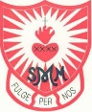
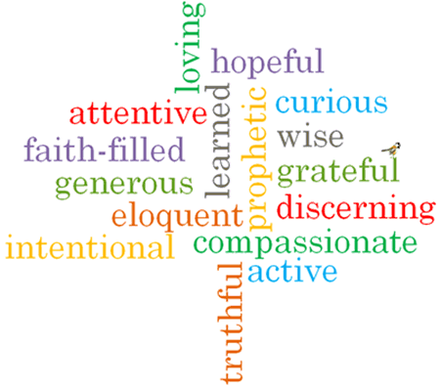
Strand: Domestic Church

Phase: UKS2
Topic: Ourselves
Come and See Knowledge Organiser
What should I already know?
The family of God in Scripture

Big Questions
Who am I?
What makes me unique?
Where do I come from?
Vocabulary I will need to use
Qualities | a distinctive attribute or characteristic possessed by someone or something.
Unique | being the only one of its kind; unlike anything else.
Gifts | a natural ability or talent.
Challenge | a call to prove or justify something.
Joys | a feeling of great pleasure and happiness.
Responsibility | having a duty to deal with something or of having control over someone.
Dignity | a composed or serious manner or style.
Image | he general impression that a person presents to the public.
Talents | natural aptitude or skill.
happiness | the feeling of being happy
peacemaker | a person who brings about peace

Scripture I will hear:
Genesis 1: 26 –28
Colossians 3: 10 -11
Colossians 3: 12-17
Philippians 4: 4-9
Hosea 11: 1-4 –

What I will learn
Make links between their beliefs about talents and qualities and how they use them and how it affects others.
Compare their own and other people’s ideas about questions of talents and qualities.
Make links between the words of Paul and the Christian’s belief in peace.
Give reasons why Christians believe in peace.

Begin to show understanding of how beliefs and values affect our love and care of each other.
Describe and show an understanding of the scripture, beliefs, feelings and the experience of being made in image and likeness of God.
Begin to show understanding of how the call to be holy shapes life
Virtues

