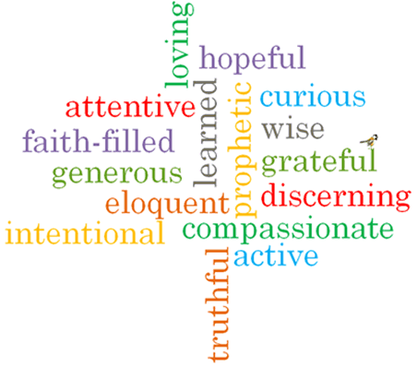

Topic: God’s People
Strand: Universal Church

Phase: LKS2
Come and See Knowledge Organiser
What should I already know?
About special places in the world for Jesus and the Christian community.
Big Questions
Why do some people do extraordinary things?
Vocabulary I will need to use
Ordinary | With no special or distinctive features, normal.
Extraordinary | Very unusual or remarkable
Admire | Regard with respect or warm approval.
Saint | A person acknowledged as holy or virtuous and is formally recognised after their death.
Martyr | A person who is killed because of their religious or other beliefs.
Communion of Saints | The spiritual union of members of the Christian Church, living and dead.
Peace | Freedom from disturbance, tranquillity
justice | Just behaviour or treatment.

What I will learn

Ask and respond to questions about their own and others’ experiences and feelings of ordinary people doing extraordinary things and be able to ask questions about what they and others wonder about ordinary people doing extraordinary things.
Retell some special stories about religious events and people who show what God is like and will be able to describe some ways in which religion is lived out by different saints.
Give reasons for certain actions by those people they have studied and be able to make links between Scripture and the action and beliefs of followers of God’s way.
Make links to show how feelings and beliefs affect their behaviour and that of others, using the example of Eric or other examples and compare their own and other people’s ideas about the question of what makes a person do extraordinary things.
Show how their own and others’ decisions about actions in life are informed by beliefs and values and describe and show an understanding of Scripture, beliefs, ideas, feelings and experience, making links between them.
Show understanding of how religious belief has shaped the way some people live out their lives.

Virtues

Scripture I will hear:

