
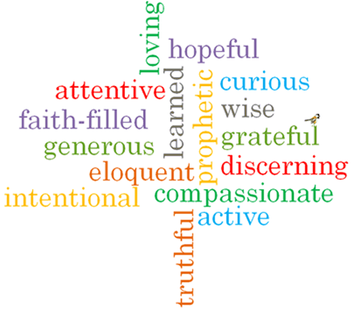
Strand: Advent/Christmas
ving
Phase: LKS2
Topic: Gift
Come and See Knowledge Organiser
What should I already know?
Advent is a time of waiting for the coming of Jesus.
Big Questions
Why are the gifts of love and friendship important?
What are the joys and demands of the commitment
required in the gift of love and friendship?

Vocabulary I will need to use
gift | A present
friendship | The relationship between friends
loyalty | The quality f being loyal.
commitment | To be dedicated to something.
rejoice | To feel or show great joy or delight.
peace | Freedom from disturbance. A feeling of tranquillity.
God’s plan | The plan God has for each one of us.

What I will learn
Ask and respond to questions about what is important in friendship.
Ask questions about what they and others wonder about the gift of love and friendship.
Retell the story of the birth of Jesus and the visit of the Wise Men.
Use religious words and phrases to describe some of the religious actions and symbols which help Christians prepare during Advent for the coming of Jesus at Christmas.
Make links to show how feelings and beliefs affect their behaviour and that of others in relation to the gift of love and friendship.
Begin to compare their own and other people’s ideas about the gift of love and friendship.
Make links between scripture texts and the belief that God sent Jesus to earth as the long-awaited Messiah.
Use a developing religious vocabulary to give reasons for the actions and symbols connected with the liturgical season of Advent and Christmas.

Virtues

Scripture I will hear:
Isaiah 40: 9-11
Matthew 2: 1-12, 16-18
Ephesians 1: 3-6
1 John 4: 4, 9-12
Philippians 4: 4-9

