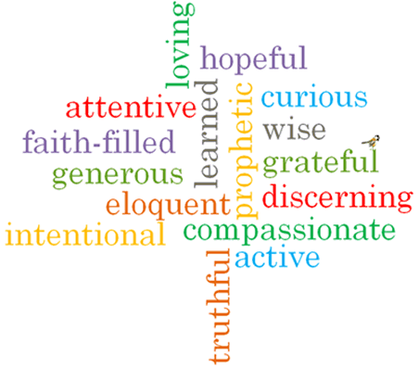
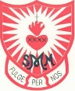
Topic: New Life
Strand: Pentecost

Phase: LKS2
Come and See Knowledge Organiser
What should I already know?
The wonder and power of the Holy Spirit.
Big Questions
How can good news change the way you feel?
How good news can bring life?
Vocabulary I will need to use
Life | The state of existence.
Good News | The positive news of Jesus and God.
Resurrection | The rising from the dead of Jesus Christ.
Pentecost | A Christian festival celebrating the descent of the Holy Spirit on the disciples of Jesus after his ascension.
Holy Spirit | The spirit form of God.
fellowship | Friendly association, especially with people who share one’s interests.

What I will learn
Ask and respond to questions about their own and others’ experiences of good news bringing life.
Ask questions about what they and others wonder about how good news brings life and happiness.
Retell some special stories about the religious events and people connected with Pentecost.
Use religious words and phrases to describe the events of Pentecost.
Describe some ways in which the apostles spread the Good News through the power of the Holy Spirit.
Make links to show how feelings of sadness and joy and the belief in the goodness of others, affects their own and others’ behaviour.
Compare their own and other people’s ideas about how good news brings life.
Give reasons why the apostles spread the Good News and the reasons for the actions of Peter, John and Paul.
Make links between the Pentecost story and the Christian belief in the new life of the Easter message through the power of the Holy Spirit.

Virtues

Scripture I will hear:
Acts 4 : 1-26
2 Corinthians 6: 3-10
Acts 8: 26-30, 34-38

