
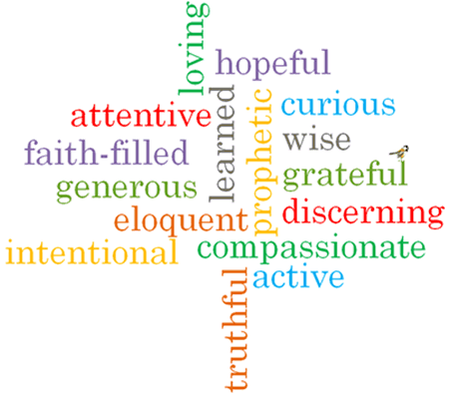
Topic: Self discipline
Strand: Lent/Easter

Phase: LKS2
Come and See Knowledge Organiser
What should I already know?
That Lent is a time to remember Jesus’ total giving.
Big Questions
How can I be self-disciplined in the choices I make?
How will self-discipline help me to grow and to reach my full potential?
Vocabulary I will need to use
Self-discipline | the ability to control one’s feelings and overcome one’s weaknesses.
Effort | An attempt at something.
Potential | Having or showing the capacity to develop into something in the future.
Penance | A punishment inflicted on oneself as a n outward expression of repentance for wrongdoing.
Contrition | The repentance of past sins during or after confession.
Lent | The period before Easter which is devoted to fasting, abstinence and penitence.
Easter | A Christian festival remembering when Jesus rose from the dead.
Resurrection | The rising of Christ from the dead.
Fasting | Not eating or drinking all or some kinds of food for a period of time.
Alms giving | The practice of giving money or food to people less fortunate.

What I will learn

Ask and respond to questions about their own and others’ experiences of being self-disciplined.
Ask questions about what they and others wonder about how people can reach their full potential.
Retell some of the religious stories of Holy Thursday, Good Friday and Easter.
Use religious vocabulary to describe some religious actions and symbols of Lent and Holy Week.
Describe some ways in which Christians try to be self-disciplined in Lent.
Make links to show how feeling and beliefs affect their self-discipline and that of others.
Compare their own and other people’s ideas about questions concerning the need for self-discipline.
Make links between religious stories of Holy Thursday, Good Friday and Easter and Christian beliefs.
Using a developing religious vocabulary, give reasons for religious actions and symbols connected to Lent and Holy Week.
Give reasons why Christians try to be self-disciplined in Lent.

Virtues

Scripture I will hear:
Matthew 6:2-4
Matthew 27:39-56
Luke 6: 27-28, 32-36
Matthew 6: 2-4
John 13: 4-9, 12-15
Mark 15: 23-41
Mark 16: 2-8

