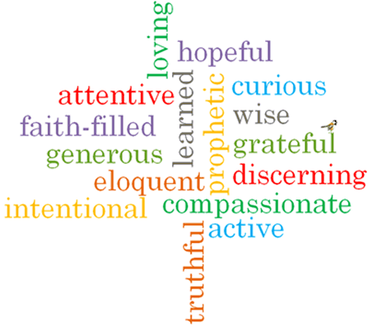
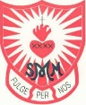
Strand: Baptism/Confirmation

Phase: LKS2
Topic: Called
Come and See Knowledge Organiser
What should I already know?
The meaning of the promises made at Baptism.
Big Questions
How does it feel to be chosen?
How do people respond to being called?
Vocabulary I will need to use
Chosen | To be selected
Response | An answer
Sacrament of Confirmation | One of the sacraments of initiation
Oil of Chrism | A special oil used during Baptism and Confirmation.
Mitre | A headdress warn by a Bishop.
Crozier | A hooked staff carried by a Bishop as a symbol of pastoral office.
Sponsor | A person who provides support for an individual.
Catechist | A teacher of the principles of Christianity.
Bishop | A senior member of the clergy, in charge of priests and deacons.
Holy Spirit | God as spiritually active in the world.
witness | A person who has seen an event occur.
anointing | To smear or rub with oil as part of a sacrament.
Holy Trinity | God in three parts; God the Father, God the Son and God the Holy Spirit.
enkindle | To inspire or arouse emotion.
called | To be asked by name to do something.

What I will learn
Ask and respond to questions about being chosen.
Ask questions about what they and others wonder about the reason for responses to being chosen.
Retell some special stories about religious events and people such as David and/ or the call of the apostles.
Use religious words and phrases to describe what it means to be called.
Describe some ways in which people are called to live a Christian life.
Make links between scripture and the call to holiness.
Make links to show how feelings and beliefs can affect the responses they might make to being chosen.
Use a developing religious vocabulary to give reasons for the actions and symbols used at Confirmation.
Give reasons why and how Christians respond to God ‘s call.

Scripture I will hear:
Samuel 2: 11, 3: 3-10, 19
Samuel 16: 4-13
Corinthians 12: 31: 13: 1-8,
Mark 1: 14-20
John 1: 5-7
Virtues

