
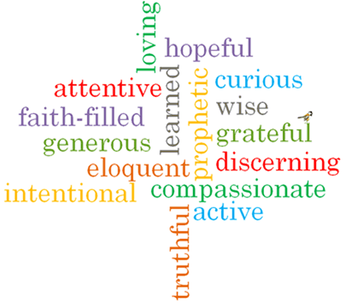
Topic: Building bridges
Strand: Reconciliation

Phase: LKS2
Come and See Knowledge Organiser
What should I already know?
The importance of conscience in making choices.
Big Questions
What might destroy a bridge of friendship?
How can bridges between people be built?
Vocabulary I will need to use
Bridges | A structure connecting 2 points
friendship | A relationship between friends
Contrition | The state of feeling remorseful and penitent.
Absolution | Formal release from guilt after confession and forgiveness.
Sacrament of Reconciliation | A sacrament in the Catholic Church which brings us closer to God.
Examination of Conscience | A review of our own thoughts, words and actions for the purpose of confession.
sin | Actions that break God’s laws.
penance | Punishment inflicted on us when we have confessed to doing something wrong.
confession | Admitting what we have done that is wrong.

What I will learn
Ask and respond to questions about their own and others’ experience and feelings about what breaks and what mends a friendship. Ask questions about what they and other wonder about how friendships may be restored. Use a developing religious vocabulary to describe some religious actions and symbols used in the Sacrament of Reconciliation. Use religious words and phrases to give reasons for some religious actions and symbols used in the Sacrament of Reconciliation.
Make links to show how feelings and beliefs affect their behaviour and that of others in respect to maintaining friendship. Compare their own and other people’s ideas about questions of building and maintaining friendship. Make links to show how feelings and beliefs about reconciliation affect their behaviour and that of others. Give reasons why believers ask forgiveness of others and forgive those who have hurt them.

Virtues

Scripture I will hear:
Colossians 3: 12-15
Matthew 5: 23-24
Luke 15:3-6,7
Mark 12: 28-31

