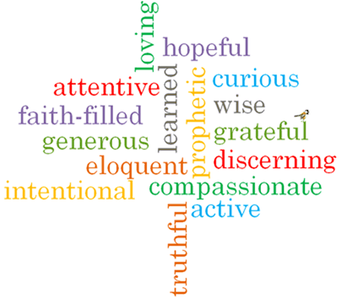

Topic: Community
Strand: Local Church

Phase: LKS2
Come and See Knowledge Organiser
What should I already know?
The Christian family’s journey with Jesus through the Church’s year.
Big Questions
Why do people give up their time to help others in the community?
What makes communities function well for the good of others?
Vocabulary I will need to use
Community | A group of people living in the same area or having something in common.
Commitment | The state or quality of being dedicated to a cause or activity.
Responsibility | The state or fact of having a duty to deal with something or having control over something or someone.
Parish | A small district or area typically with its own church and priest.
Laity | Members of a parish who are not ordained – the ordinary people.
Ministries | The work or vocation of a minister of religion.
Extraordinary Ministers | A member of the laity who has been given special permission to distribute the Holy Eucharist.
service | An act of worship.
Funeral rites | Practices followed by the Catholic church at a funeral service.
Pastoral area | A cluster of neighbouring parishes that work together.
deanery | Parishes assembled in smaller geographical groups, working under the care of a ‘dean’.

What I will learn
Ask and respond to questions about their own and others’ experiences of being part of a community.
Ask questions about what they and other wonder about the responsibility and commitment of belonging to a community.
Retell the story of the call of the apostles.
Some children will be able to describe some of the advice St. Paul gives us about being loving members of a community.
Use religious words and phrases to describe the actions and symbols within a funeral Mass.
Describe some ways in which some people serve their parish community.
Make links to show how feelings and beliefs affect their commitment to community and that of others.
Make links between the call of the apostles and God’s call to people to serve him today.
Use a developing religious vocabulary to give reasons for the actions and symbols used within a funeral Mass.
Some children will be able to give reasons why people give service to the parish community through various ministries.

Virtues

Scripture I will hear:
Romans 12: 8-11
Mark 3: 13-19
Acts 6: 2-13; 7: 57-60

