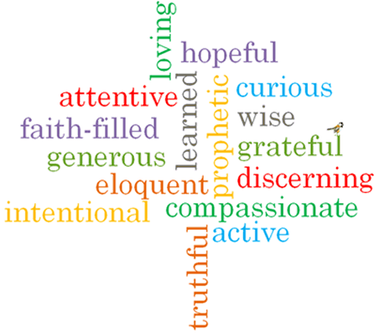

Strand: Domestic Church

Phase: LKS2
Topic: People
Come and See Knowledge Organiser
What should I already know?
God’s vision for every family.
Big Questions
Where do I come from?
To whom do I belong?
To which family did Jesus belong?
Vocabulary I will need to use
Chosen people
Siblings | Brothers and sisters
Relations | Members of your family
Ancestors | People we are descending from.
Generations | People born and living at the same time.
Old Testament | The part of the Bible written before Jesus was born.
Roots | The base of a family tree.
Family tree | A map of who is part of a family and who we are related to.
Genealogy | The study of family history.
Nomad | A member of people that travels from place to place.
nomadic | Living the life of a nomad; wandering.

Scripture I will hear:
Matthew 1: 1-17
Mt 2: 13-15, 19-23,
Lk 2: 40-51,
Mk 1: 14-20
Genesis 12: 1-8, 18
Genesis 21: 1-7
Genesis 25: 20-27
Genesis 35: 9-15, 23-26
Ruth 1: 2-7, 16, 17
1 Kings 1, 2, 4

What I will learn
Compare their own and others’ ideas about the questions that family trees raise and are difficult to answer.
Make links between these stories and what people believe about God and Jesus.
Give reasons for certain actions by believers such as Ruth.
Describe and show understanding of the roots of Jesus’ human family.
Describe and show understanding of what Christians believe about how God leads and guides people.

Virtues

