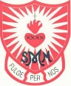
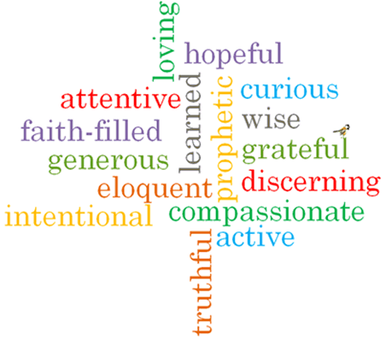
Strand: Advent/Christmas

Phase: LKS2
Topic: Visitors
Come and See Knowledge Organiser
What should I already know?
Advent: four weeks of preparation for the celebration of the birth of Jesus at Christmas

Big Questions
How visitors are welcomed
The joys and demands of visitors
Vocabulary I will need to use
Messiah | The saviour of the people
Annunciation | The announcement by Angel Gabriel to the Blessed Virgin Mary that she would have a baby called Jesus by the Holy Spirit
Magnificat | The prayer of Mary when she goes to visit Elizabeth.
Isaiah | A prophet who saw the coming of Jesus Christ as the Messiah 700 years before.
Nativity | The birth of Jesus Christ
The Visitation | When Mary visited Elizabeth whilst pregnant with Jesus
Joyful Mysteries | The story of Mary that we can think about when we pray the Rosary
Joys
demands
visitors
Advent

What I will learn
Ask and respond to questions about their own and others’ experiences and feelings about the events which mark the year or the season.
Ask questions about what they and others wonder about how we help one another on the journey through the year.
Retell some of the stories of the Mysteries of the Rosary or the special feasts of the year.
Use religious words and phrases to describe the liturgical year and how it is composed of seasons and feasts days.
Describe how some prayer leads to good actions.
Make links to show how feelings and beliefs affect how they and others behave in their life journey and what is important to them.
Make links between some scripture and what Christians believe.
Use a developing religious vocabulary to begin to give reasons why Catholics celebrate certain feasts of the year and the reasons for the actions and symbols used.

Scripture I will hear:
Isaiah 11: 1
Isaiah 40: 3-5
Romans 13:9b-13a
Luke 1: 26-31, 38 -58
Luke 2: 1-20
Matthew 2: 1-12, 16-18,

Virtues

