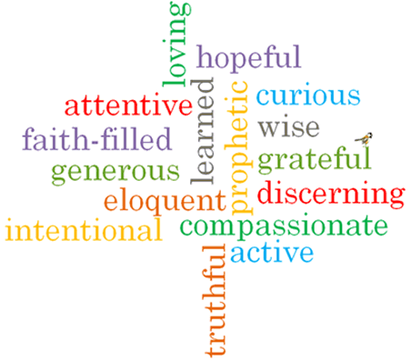
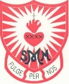
Topic: Energy
Strand: Pentecost

Phase: LKS2
Come and See Knowledge Organiser
What should I already know?
Pentecost, spreading the Gospel message through the gift of the Holy Spirit.
Big Questions
How can the energy of the wind be used for good?
How the Holy Spirit inspires Christians?
Vocabulary I will need to use
Fire | The heat, light, and flames produced by burning.
Holy Spirit | The third person of the Trinity; God as spiritually active in the world.
Energy | The power by something.
Power | The feeling of strength.
Rosary | A prescribed series of prayers recited by Roman Catholics to the Virgin Mary.
Glorious Mysteries | The part of Jesus’ life after he died. He ascended into Heaven, the Holy Spirit came to the Apostle’s and Mary’s Death.
Pentecost | A Christian festival on the seventh Sunday after Easter, celebrating the descent of the Holy Spirit on the Apostles of Jesus Christ.
warmth
wind
gifts

What I will learn
Ask and respond to questions about their own and others’ experiences and feelings about the power of fire and wind and how this energy can be used for good.
Ask questions about what they and others’ wonder about the power of wind and fire and realise that some of these questions are difficult to answer.
Retell the story of the Ascension and the coming of the Holy Spirit at Pentecost.
Use religious words and phrases to describe what happened to the apostles at Pentecost, what they saw and felt.
Describe some ways in which Christians live when they use the energy and gifts of the Holy Spirit.
Compare their own and other people’s ideas about questions that are difficult to answer about the best use of the power of wind and fire.
Make links between the Pentecost story and Christian belief in the power of the Holy Spirit.
Give reasons for the love Christians show because they are inspired by the Holy Spirit.

Scripture I will hear:
Matthew 28: 1-10
John 16: 5-7
1 Corinthians 12: 4-8, 11
Acts 1: 6-11
Acts 2: 1-18, 43,
Isaiah 11: 2
Virtues

