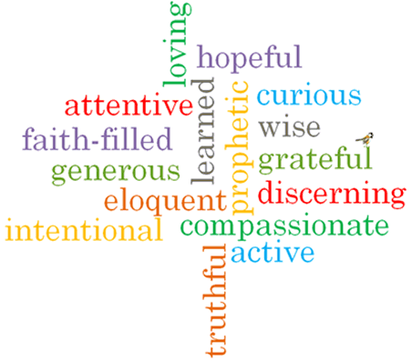
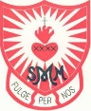
Strand: Baptism/Confirmation

Phase: LKS2
Topic: Promises
Come and See Knowledge Organiser
What should I already know?
Signs and symbols used in Baptism
Big Questions
What does it mean to make a promise?
How can we help others keep promises?
Vocabulary I will need to use
Symbols | Something that represents or stands for something else.
Sacrament | A religious ceremony sharing God’s grace such as Baptism, First Holy Communion and Reconciliation.
Faith | Belief and trust in God.
Ceremonies | A formal occasion to celebrate a particular event.
Anointing | Smear or rub with oil.
Trinity | The three parts of God: God the Father; God the Son; and God Holy Spirit.
Commitment | Being dedicated to something.
Promises
rules
actions
rite
Sacrament
welcome
Church
Chrism

What I will learn

Ask and respond to questions about promises.
Ask questions about what they and others wonder about why people make promises.
Retell the story of the Baptism of Jesus.
Describe the actions and symbols used at Baptism.
Make links between their actions and the promises made.
Use a developing religious vocabulary to give reasons for the actions and symbols used at Baptism.
Give reasons for the promises made at Baptism.
Give reasons how and why Christians live as followers of the Light of Christ.

Scripture I will hear:
Jeremiah 31: 3
Mark 1: 9-11

