
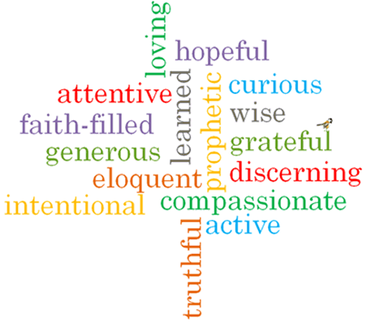
Topic: Special Places
Strand: Universal Church

Phase: LKS2
Come and See Knowledge Organiser
What should I already know?

Big Questions
Where is special for me?
How do places become special?

Vocabulary I will need to use
Pilgrim | A person who makes a special journey of spiritual and moral significance
Pilgrimage | A special place that reminds people how important it is to pray and take time to think about what is important in their lives
Universal Church | The Catholic Church and all the people within it
Temple | A temple is a building for spiritual or religious rituals
Nazareth | The place where Jesus grew up. This is in Israel.
Special | Better or greater from what is usual. Jesus is special in our lives.
Holy place | A place that is Holy and special to a religion

Scripture I will hear:
Psalm 24:1

Virtues

