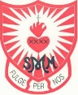
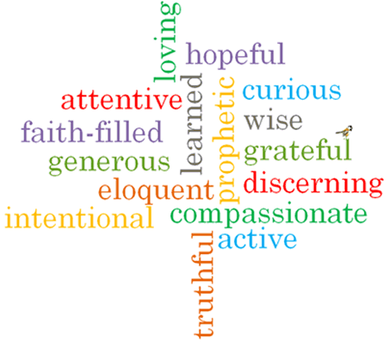
Strand: Local Church

Phase: LKS2
Topic: Journeys
Come and See Knowledge Organiser
What should I already know?
The books used in Church on Sunday by the parish family
Big Questions
How events mark the journey through the seasons of the year?
How we can help one another in life’s journey?
Vocabulary I will need to use
Our Lady | Mother of Jesus, Mary. Also the mother of the catholic church.
Calendar | a chart or series of pages showing the days, weeks, and months of a particular year, or giving particular seasonal information
Season | each of the four divisions of the year spring, summer, autumn, and winter
Journey | a long and often difficult process of personal change and development
Liturgical | public worship
Feast day | a day on which a Christian celebration is held.
Ordinary time | The time in the church calendar that is not a feast day, celebration or a preparation for a celebration eg lent or advent. At this time the priest will wear green
feast day

What I will learn
Ask and respond to questions about their own and others’ experiences and feelings about the events which mark the year or the season.
Ask questions about what they and others wonder about how we help one another on the journey through the year.
Retell some of the stories of the Mysteries of the Rosary or the special feasts of the year.
Use religious words and phrases to describe the liturgical year and how it is composed of seasons and feasts days.
Describe how some prayer leads to good actions.
Make links to show how feelings and beliefs affect how they and others behave in their life journey and what is important to them.
Make links between some scripture and what Christians believe.
Use a developing religious vocabulary to begin to give reasons why Catholics celebrate certain feasts of the year and the reasons for the actions and symbols used.

Scripture I will hear:
Psalm 84
Psalm 118 – 19-20, 26-29
Psalm 122: 1-9
Virtues

