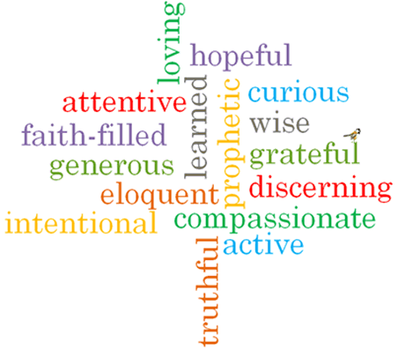

Strand: Domestic Church

Phase: LKS2
Topic: Homes
Come and See Knowledge Organiser
What should I already know?
God is present in every beginning
Big Questions
What does home mean to you?
How is God present in my life?
Vocabulary I will need to use
Sorrows | A feeling of deep distress caused by loss, disappointment, or other misfortune.
Community | A group of people living in the same place or having a particular characteristic in common.
Family | A group of people who are related to each other.
Home | The place where a person lives, often with their family.
Love | Strong and warm affection between people.
Difference | What makes two or more persons or things not the same.
Respect | A way of treating or thinking about something or someone with kindness.
joys

What I will learn
Ask and respond to questions about their own and others’ experiences and feelings about homes.
Ask questions about what they and others wonder about what makes a house a home and realise that sometimes this is a difficult question to answer.
Retell some of the advice offered by Paul in his letters about living together as a family and the life of the Holy Family.
Describe some ways Christians live as people chosen by God.
Ask questions about what they and others wonder about how God is always with us, and realise that this is a difficult question to answer.
Make links to show how feelings and beliefs affect how they, their behaviour and that of others in relation to the give and take of living in a family.
Compare their own and other people’s ideas about the difficult question of what make a house a home.
Make links between some scripture they have studied and the belief that God can make a difference in everyday life through God’s unchanging love.
Give reasons why Christians should try to love others.
Compare their own and others’ ideas about what they and others wonder about how God is always with us, and realise that some questions are difficult to answer.

Scripture I will hear:
Romans 12: 8-13
Ephesians 5: 1-9; and 6: 1-4.
Luke 2: 39-40
John 13:34-35
Col 3:12-17
Virtues

