
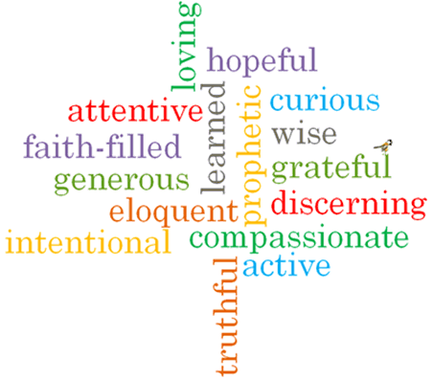
Virtues

Scripture I will hear:

Big Questions
Is the world a treasure?
Topic: Treasures
Strand: Universal Church

Phase: KS1
Come and See Knowledge Organiser
Vocabulary I will need to use
treasure | Something precious to somebody, it doesn’t always cost a lot of money.
gift | A present
care | Looking after and provide for the needs of someone or something.
love | A feeling when you like something very much.
protect | Looking after something and keeping it safe from harm.
respect | Showing that you value something or someone.
Preserve creation | Taking care of what has been given to us and made by God.
precious | Something of great value that shouldn’t be wasted or treated carelessly.

What I will learn
Talk about their own experience and feelings about the treasures they see or have and be able to say what they wonder about the treasures they see or have.
Ask and respond to questions about their own and others’ experiences of and feelings about what we treasure.
Ask questions about what they and others wonder about the treasures of our world and realise that some of these questions are difficult to answer. Retell some special stories about creation and the treasures of God’s world and be able to describe some ways in which religion is lived out by believers in the way they treasure God’s world.
Compare their own and others’ ideas about questions about the treasures of our world that are difficult to answer. Children will be able to make links between religious stories about creation/ treasuring our world and beliefs and be able to give reasons for certain actions by believers in relation to treasuring God’s world.
Make links between how they feel about their treasure and how that might affect their behaviour and that of others.

What should I already know?
Everyone in the world is our neighbour and is loved by God.

