
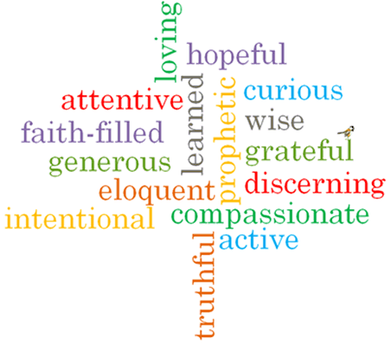
Virtues

Scripture I will hear:
Luke 22: 19-20
Topic: Thanksgiving
Strand: Eucharist

Phase: KS1
Come and See Knowledge Organiser
Vocabulary I will need to use
Thank you | A polite phrase used to recognise how you feel when you receive something.
Thanksgiving | An expression of gratitude (being thankful) to God.
Thoughtful | Showing consideration for the needs of others.
Eucharist | The Catholic sacrament remembering the Last Supper in which bread and wine is turned into Jesus’ body & blood and eaten.
Eucharistic prayer | A prayer said during the mass.
liturgy | A form of worship.

What I will learn

Talk about their experience of receiving and giving thanks.
Say what they wonder about how others feel when they are thanked.
Recognise the story of the Last Supper.
Recognise signs and symbols, different words and phrases used in the Eucharist (at Mass) to give thanks.
Recognise that Catholics go to Mass to remember what Jesus did at the Last Supper and give thanks to God.
Ask and respond to questions about how they and others feel when receiving and giving thanks.
Retell the story of the Last Supper.
Use words and phrases to describe some religious signs and symbols.
Use words and phrases to describe the steps involved in the Eucharist (Mass) showing how Catholics give thanks to God.
Describe how Catholics try to live what they have experienced at Mass in their daily lives.

What should I already know?
That the Mass is Jesus’ special meal.
Big Questions
Why it is important to say thank you?
How it feels to say thank you?
How it feels to be thanked?

