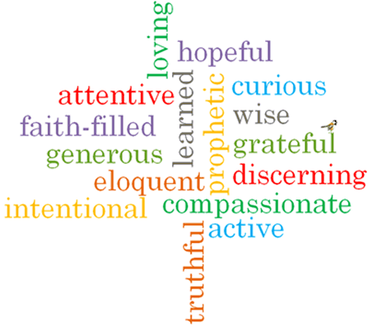

Strand: Domestic Church

Phase: KS1
Topic: Beginnings
Come and See Knowledge Organiser
Virtues

Scripture I will hear:
Genesis 1: 3, 9, 20, 24-26
Psalm 8: 3-11
Psalm 139: 14-18
Psalm 19: 1-5
Ephesians 1: 3-5
Big Questions
Where do I come from?
Why are some beginnings easy and some difficult?
Will there be many beginnings in my life?
Vocabulary I will need to use
beginning | The start of something.
New start | When a new activity or event begins.
family | People who are related to one another.
friend | A person we have shared likes and experiences with.
creation | When an object I made.
psalm | A song or collection of verses with a religious theme, used in Christianity and Judaism.
litany | A series of prayers.

What I will learn
Talk about their experience and feelings about new beginnings.
Say what they wonder about the excitement and surprise that a new start can bring.
Recognise the story of Creation as a religious story.
Recognise and use some religious words and phrases about types of prayer.
Recognise that people are kind and loving because God made them.
Ask and respond to questions about their own and others’ experiences about new beginnings.
Ask questions about what they and others wonder about the reasons for some beginnings being easy and others difficult and realise that some questions are difficult to answer.
Retell the story of Creation as a religious story or some phrases from the psalms.
Describe and use some religious words and phrases about types of prayer.
Describe that people are kind and loving because God made them.
Ask questions about what they wonder about the beauty around them and God creating the world.

What should I already know?
God’s love and care for every family.
Jesus was born and lived in a human family.

