
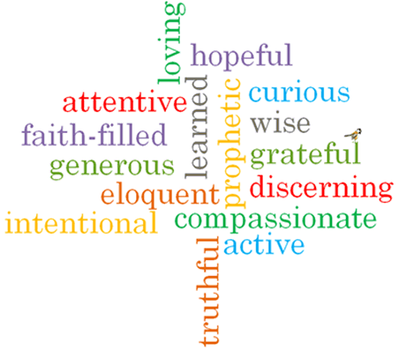
Topic: Preparations
Strand: Advent/Christmas

Phase: KS1
Come and See Knowledge Organiser
Virtues

Scripture I will hear:
Isaiah 9: 2, 6
Luke 1: 26-31, 38, 39-45
Luke 1: 45-55
Luke 2: 1-7
Big Questions
Why is it necessary to prepare?

Vocabulary I will need to use
preparing | Actions we complete to get ready for an event.
Advent | The first season of the Church year, leading up to Christmas. It last for four weeks.
Christmas | A Christian festival celebrating the birth of Jesus Christ.
Nativity | The birth of Jesus Christ.
waiting | The time we spend preparing for something to happen.
Annunciation | The announcement made by the Angel Gabriel to Mary that she would have God’s son, Jesus Christ.
Visitation | The visit Mary made to her cousin Elizabeth.

What I will learn
Talk about their own experience and feelings of preparing for special occasions.
Say what they wonder about the amount of time and care involved in preparing for Christmas.
Recognise the events around the birth of Jesus as religious stories.
Recognise some religious signs and symbols and use religious words and phrases connected with the liturgical season of Advent.
Recognise that Christians, through their actions follow Jesus as the Light of the World.
Ask and respond to their own and others, experience and feelings, about how important it is to prepare well and what happens if there is no preparation.
Ask and respond to questions about they and others wonder about the amount of time and care involved in preparing for Christmas and realise that some of these are difficult to answer.
Retell the stories of the Annunciation, the Visitation and the Nativity and be familiar with the characters in those events.
Use religious words and phrases to describe some religious actions and symbols connected with the liturgical season of Advent.
Describe how Christians follow Jesus as the Light of the World and live that out in their lives.

What should I already know?
That Advent is a time of waiting to celebrate Jesus’ coming at Christmas.

