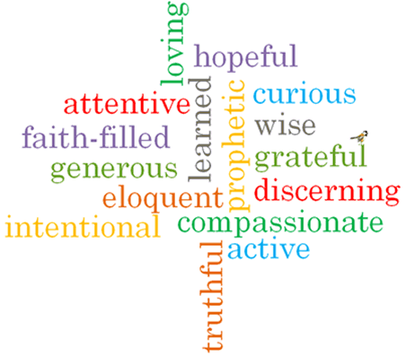

Virtues

Scripture I will hear:
Luke 24: 48-52
Luke 24: 1-9
Act 2: 1-4 –
I Thessalonians 4: 13-14, 18
John 13: 33; 14:18, 15, 26; 16:5,7,13

Topic: Spread the Word
Strand: Pentecost

Phase: KS1
Come and See Knowledge Organiser
Vocabulary I will need to use
Message | Information that can be shared in different ways.
Risen | To be lifted up.
Resurrection | To come back to life again.
Holy Spirit | The Spirit form of God.
Ascension | A Christian feast remembering when Jesus returned to heaven to be with his Father.
Witness | Somebody who has seen something happening.
Blessing | A prayer asking for divine favour and protection.
Pentecost | A Christian feast remembering when the disciples received the gift of the Holy Spirit and began their mission of spreading the Good News of God.
Promise | An agreement between people that they will do something.
Good News | The message of Jesus and God and the goodness they can bring to people’s lives.

What I will learn

Talk about their own experience and feelings of both passing and receiving messages.
Say what they wonder about the importance and responsibility of passing on messages in daily life.
Recognise the stories of Jesus’ Resurrection and the coming of the Holy Spirit at Pentecost as religious stories.
Recognise how the disciples changed through the power of the Holy Spirit.
Recognise how the Holy Spirit helps Christians in their lives.
Say about what they wonder about Jesus’ new life and the coming of the Holy Spirit.
Ask and respond to questions about their own and others experiences and feelings of both passing and receiving messages.
Retell the story of the Resurrection of Jesus and the coming of the Holy Spirit.
Describe ways in which Christians spread the word of the Good News of Jesus in their lives.

What should I already know?
Pentecost is a Holy day – the feast of the Holy Spirit.
Big Questions
What responsibilities are involved in passing on messages?
Which is the best way to pass on messages?

