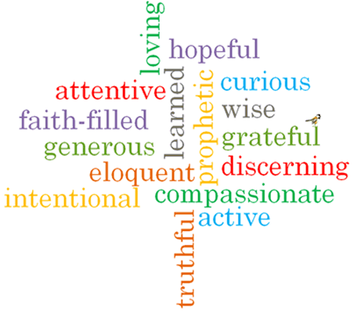

Virtues

Scripture I will hear:
John 15: 12
Colossians 3: 10-17
Matthew 18: 21-22

Topic: Rules
Strand: Reconciliation

Phase: KS1
Come and See Knowledge Organiser
Vocabulary I will need to use
rules | Guidelines on things we should or should not do.
care | How we treat others.
safe | A feeling when we are away from any harm.
sorry | A feeling when we have done something wrong and we regret what we have done.
forgive | To stop feeling angry or resentful towards someone else.
right | Something that doesn’t break rules.
wrong | Actions that break the rules.
Make up | An action when we forgive somebody.
choices | Options we make.
sin | An action that breaks God’s laws.
consequences | What can happen as a result of our actions.
Examination of conscience | Reviewing our thoughts ad actions and what we have done wrong before we confess our sins.

What I will learn

Talk about their own experience and feelings about rules in their life.
Say what they wonder about the importance of keeping rules for themselves and for others. Recognise the story of Peter asking Jesus about forgiveness as a religious story. Recognise some religious words and signs that Christians use to express sorrow and forgiveness. Recognise that people say sorry and ask forgiveness because they are followers of Jesus.
Ask and respond to questions about their own and others’ experiences and feelings of the importance of rules.
Use religious words and phrases to describe the examination of conscience. Describe some aspects of the Sacrament of Reconciliation. Describe how Christians try to practice Jesus’ commandment of love, peace and reconciliation.

What should I already know?
God helps us to choose well and to be sorry. God forgives us.
Big Questions
Why are rules important?
Why is it good to say sorry?

