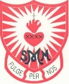
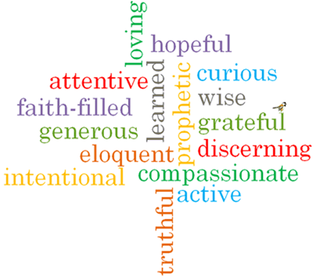
Virtues

Scripture I will hear:
Matthew 3: 13-17
John 13: 34-35
Topic: Books
Strand: Local Church

Phase: KS1
Come and See Knowledge Organiser
Vocabulary I will need to use
Books
Library | A collection of books stored in one place.
Text book | A book that is usually used in schools and contains information.
Reverence | To show deep respect for someone or something.
Respect | A feeling of admiration for someone or something.
Scripture | Sacred writings.
lectern | A tall stand with a sloping top to hold a book. Used in Church to hold the Bible which is read from.
Gospel | The teaching of Christ told by Matthew, Mark, Luke and John.
Bible | Christian scripture made up of the Old and New Testament.
Old Testament | The first part of the Bible containing stories from the Prophets.
New Testament | The second part of the Bible containing the Gospels and other books with stories of Jesus’ life and teaching.
genre | A style or category of writing.
thurible | A vessel made of metal that is used to burn incense.
missal | A book containing the texts used in the Catholic Mass.

What I will learn
Talk about their experience and feelings of books that are used at home and school.
Say what they wonder about the importance of books in their lives.
Recognise that the Bible is a special book and name some of the stories in the Bible.
Recognise and name some of the special books used in church and the people who use them.
Ask and respond to questions about their own and others’ experience and feeling of the different books that are used at home and school.
Retell the story of the Baptism of Jesus.
Describe how the Gospels are used by the parish family.
Use religious words and phrases to describe the actions and symbols related to proclaiming the Gospel.

What should I already know?
That on Sunday in Church, we meet people who do special jobs as we gather to celebrate the Good News of Jesus.
Big Questions
Why do we need books?
How many kinds of books do we use and why? What is special about the Bible and why it is important to us?

