
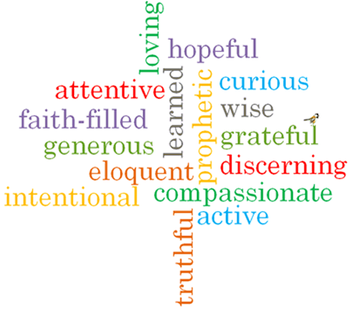
Strand: Universal Church

Phase: KS1
Topic: Neighbours
Come and See Knowledge Organiser
Scripture I will hear:

Virtues

Big Questions
Who is my neighbour? Why are they my neighbour? What makes a good neighbour? How can you be the best friend you can be? What is CAFOD?
Vocabulary I will need to use
Neighbour- | Neighbour- a person living close by or who is ‘close to us’.
World | the planet we live on.
Fairtrade | where things are bought and sold in different countries for fair prices.
Global | around the world.
Family | who we are related to and love.

What I will learn

What should I already know?

