
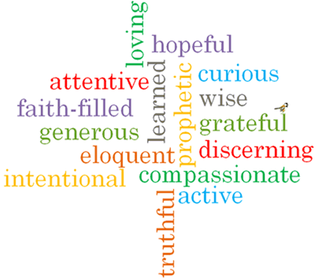
Strand: Pentecost

Topic: Good News
Come and See Knowledge Organiser
Phase: EYFS
What I will learn
I will begin to talk about how they feel when they have good news to share.
Say what they wonder about the joy good news brings.
Begin to talk about how they feel when they hear Good News.
Begin to say what they wonder about Pentecost Day and the Holy Spirit.
Recognise the Pentecost story as a religious story.
Use and recognise religious words and phrases.
Recognise that Christians are happy at Pentecost and go to church to celebrate the Good News.

Vocabulary I will need to use
Passing on the Good news of Jesus
Good news
Share
Pentecost | The beginning of the church.
Promise | An agreement to do something
Holy Spirit | The spirit of God present in our lives.
Easter | The celebration of when Jesus died and rose from the dead.
Alleluia | A word to praise God.

Virtues

Scripture I will hear:
Acts 2: 1-4

Big Questions
What is Good News?
Who is the Holy Spirit?
What should I already know?
The ways in which we grow & that Lent is a time to grow more like Jesus & look forward to Easter.

