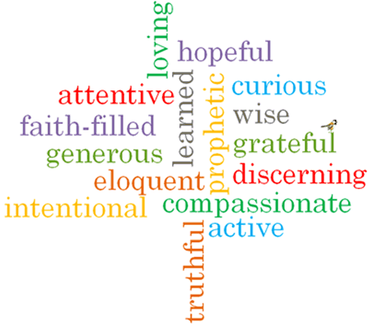
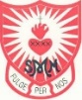
Come and See Knowledge Organiser
Strand: Universal Church

Phase: EYFS
Topic: Our World
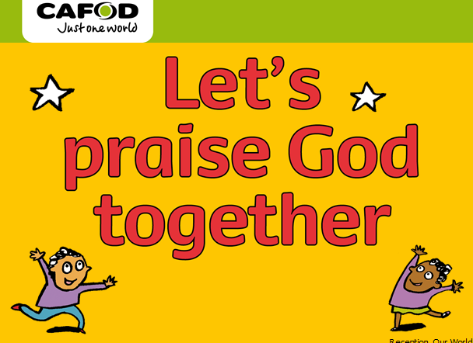
Scripture I will hear:
Genesis 1: 3, 9, 20, 24−26,
Psalm God’s Story 1

Big Questions
What makes our world so wonderful?
What I will learn
Recognise some words and phrases from the Psalms.

Recognise that people want to take care of the world and share with others because God said, “Take care of my world!”
Say what they wonder about the world and how we can all work together to care for the world.
Talk about their own experiences of the world and what they love about our world.

What should I already know?
We can make friends and Jesus had good friends.
Vocabulary I will need to use
World
Wonder
wonderful
Care
Love
Share
together

