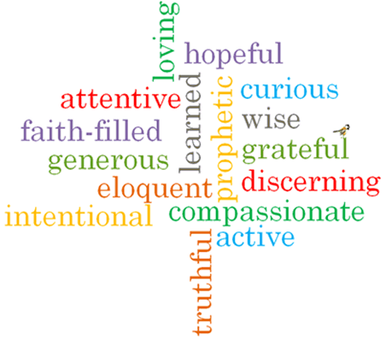

Strand: Reconciliation
Topic: Friends
Come and See Knowledge Organiser
Phase: EYFS
Vocabulary I will need to use
Friends of Jesus
Jesus | The son of God.
Rule | Instructions on things we should or shouldn’t do.
Understanding | how we use what we know in our lives.
New start | A new beginning.
Friendship | The relationship between friends
Forgive | An action when somebody says sorry
change | When something different happens

Virtues

Scripture I will hear:
Mark 6: 7, 30-32
John 13: 34
John 13: 34-35
Big Questions
Is it good to have friends?
Who are your friends?
Why are they your friends?
Are you anyone’s friend?
What I will learn
Talk about their experiences and feelings about what a friend is.
Talk about making friends and when friendships go wrong.
Wonder about what makes people friends.
Recognise that Christians show love for one another because Jesus asked them to do so. Recognise Jesus’ rule for friends and his words ‘love one another’.

What should I already know?
That everyone has good news, and that Pentecost is the celebration of the Good News of Jesus.

