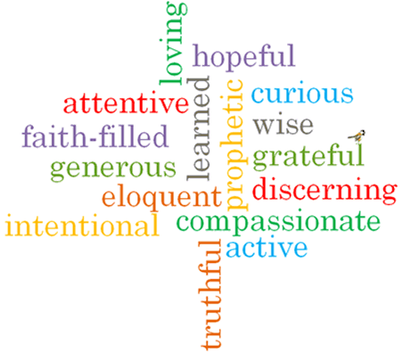
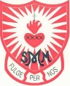
Strand: Baptism/Confirmation
Topic: Welcome
Come and See Knowledge Organiser
Phase: EYFS
Virtues

What I will learn
I will begin to talk about my own experiences and feelings of being welcomed.
I will begin to say what I wonder about how they can make others feel welcome.
I will begin to recognise some religious signs and symbols used in baptism.
I will begin to use some religious words and phrases from the Rite of Baptism.

Vocabulary I will need to use
a welcome for a new baby
Welcome | Greeting someone in a polite or friendly way
Welcomed | How we make people feel when we welcome them
Belong | To be part of or a member of a group.
School | A building where we come together to learn.
Class | A group of children with teachers.
Baptism | A time where we are welcomed into God’s family and given a special name.
baptise | When a baptism takes place and water is poured onto the head of the person being welcomed into God’s family.
Water | A liquid that can be blessed to make it Holy.
Candle | A solid object made of wax which can be lit. The flame can represent Jesus being the light of the world.
In the name of… | Words we say at the start of a prayer.
family | People who we are related to.
priest | A man whose job it is to tell people about God and Jesus.
White garment | White clothes we wear when we are baptised.
Godparents | Adults that parents ask to do a special job to help raise a baby following God’s teachings.
font | A special container or bowl of Holy Water that is used when a person is baptised.

Scripture I will hear:
Colossians 3:12
What should I already know?
Children will have experience of belonging to a family and to a class group in school.
Big Questions
Why is welcome important?
How do we show people that they are welcomed?
How is a baby welcomed into a family?
How are we welcomed into God’s family?

