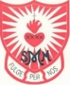
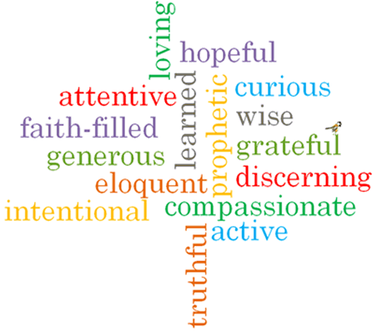
Strand: Local Church
Topic: Celebrating
Come and See Knowledge Organiser
Phase: EYFS
Vocabulary I will need to use
People celebrate with the parish family
Church | a group of people called together to worship Jesus and God. This can be done in a building known as a Church.
Priest | A man whose job it is to tell and teach people about God and Jesus Christ his son.
Celebrate | Mark a special event with a gathering or special activity.
Celebrating | The action of marking a special event or occasion.
Parish family | A group of people belonging to a Church in a local area.
Family | People who are related to each other.
Community | People who live or work in an area together.
Celebration | The event that is used to mark a special occasion.
Party | A celebration of an event.
Memory | Something remembered that has already happened.
Father | A man who has a child, for example God is Jesus’ Father.
Altar | A special table in a Church.
Temple | A place where Jewish people go to pray and worship God.
parish | A local area of a Church community.

What I will learn
I will begin to talk about my own experiences and feelings about celebrations I have been part of and how the celebration was shared.
I will begin to wonder about why people celebrate.
I will begin to wonder about how I feel when I celebrate.
I will begin to recognise the story of Mary and Joseph taking Jesus to the Temple.
I will begin to recognise some of the elements and words used in Church celebrations.
I will begin to recognise that the church/parish family celebrate in particular ways.

What should I already know?
Children will have experienced celebrations at home.
Virtues

Scripture I will hear:
Luke 2: 22
Big Question
What and why do people celebrate?
Can you celebrate on your own?

