
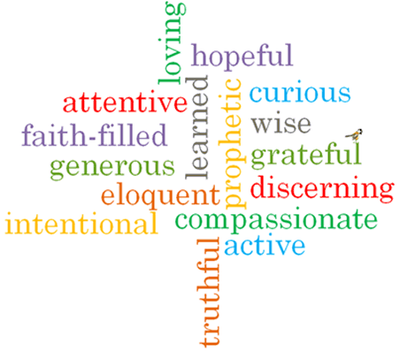
Strand: Lent/Easter

Phase: EYFS
Topic: Growing
Come and See Knowledge Organiser
Virtues

What I will learn
I will learn to talk about my experience of growing and how I feel about it.
I will begin to say what I wonder about.
I will recognise the stories of Good Friday & Easter Sunday.
I will begin to recognise the cross, the words of the Sign of the Cross & the Easter garden.
I will begin to recognise that Christians try to ‘grow more like Jesus’ particularly during Lent.
Scripture I will hear:
John 13: 34-35
John 19: 25-27
Acts 2: 23-24
Luke 2: 51-52
Big Questions
How and why do things grow?
How do things grow?
What do things need to grow?
How do I grow ‘Inside’?
Vocabulary I will need to use
Looking forward to Easter
grow | Something gets older.
spring | A season when things begin to grow.
different | Not the same.
Lent | A season of reflection and preparation. Last for 40 days and 40 nights beginning on Ash Wednesday.
Good Friday | The day Jesus was crucified and died.
Cross | A wooden shape that Jesus died upon.
Easter Sunday | The day Jesus rose from the dead.

What should I already know?
Knowledge and experience of activities that are good to do together.

