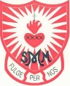
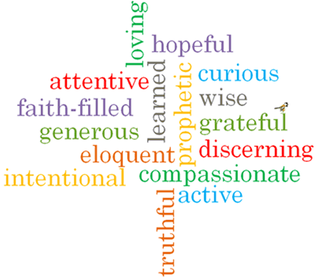
#
Topic: Family
Come and See Knowledge Organiser
Phase: EYFS
Strand: Domestic Church
What I will learn
I will be able to talk about my own feelings.
I will talk about my experiences of being known and called by name.
I will be able to recognise some phrases from the Psalms which tell about God’s love for them.

Vocabulary I will need to use
God knows and loves each one
Christian | Somebody who believes that Jesus Christ is God’s son and follows the example he sets for us.
First name | The name given to us by our parents that people use when they want to speak to us.
Family name | The name other people in our family might have in common.
precious | Something of great value that shouldn’t be wasted or treated badly.
parent | A person’s Mummy or Daddy.
God | God is the creator – the source of al life. God is our father.
love | A feeling we can experience.
loving | Feeling or showing love
prayer | An action where we speak to God.

Virtues

Scripture I will hear:
Isaiah 43: 1-2 God’s Story 1
Psalm 131 God’s Story 1
Big Question
Why am I precious?
How do I know God loves me?
What should I already know?
Children will have experience of being part of a family.

