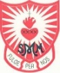
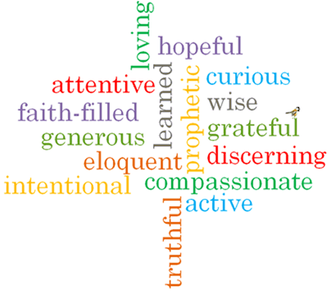
St Margaret Mary’s - Science Curriculum Overview 2024-25
 | Autumn 1 | Autumn 2 | Spring 1 | Spring 2 |  | Summer 1 | Summer 2
EYFS | People Who Help Us | Rumble in the Jungle | Hop On-board | To the Rescue |  | Ready Steady Grow  Precious Planet | Commotion in the Ocean
KS1 | Seasonal Changes (2 lessons – Autumn) | Seasonal Changes (2 lessons Winter) |  | Seasonal Changes (2 lessons Spring) |  |  | Seasonal changes (Summer)
Year 1 | Transition topic:  5 senses/ floating and sinking/forces | Animals including Humans | Everyday Materials | Animals including Humans | Plants
Year 2 | Living things and their habitats. | Animals including Humans | Uses of Everyday Materials | Animals including Humans | Plants
LSK2 | Sound  (4) | Forces and magnets  (3) | States of matter  (4) | Plants  (3) |  | Plants  (3) |  | Animals including humans  (4)
Year 5 | Forces | Earth and space | Changing states | Animals including humans |  | Living things and their habitats
Year 6 | Electricity | Light | Animals including humans | Evolution and inheritance |  |  | Living things and their habitats
Key dates:
Space Week – 4th – 10th October
Science Week - 7th – 16th March 2025
Great Science Share – Tuesday 17th June 2025

