Friday 16th June 2017
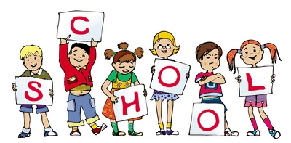

General Reminders
- Sun cream and sunhats – please ensure all children have sun cream applied before they come to school and bring sunhats into school during the summer months. Sunglasses will not be allowed.
- Please make sure that your child’s P.E kit is in school on a daily basis.
- Chair of governors Eddie Roberts can be contacted by email – chair@pikefold,manchester.sch.uk
- Family engagement officer: Mrs J. Gallimore. Tel: 0161 795 4614

Welcome to the Key Stage One newsletter! Thank you to the parents who have emailed your questions. Our enquiry email is ks1parents@pikefold.manchester.sch.uk.
Huge congratulations to Year 1 for all trying so hard in their Phonics Screening!
On Wednesday the whole school enjoyed a Healthy Living day and took part in Joe Wick’s School Workout. Today we have been very fortunate to welcome the NSPCC to our school. All children were present for their Speak Out, Stay Safe assembly this morning.
Next week we are having two transition mornings, the children will get the opportunity to visit their new classroom and meet their new teacher.
Polite reminders: Please assure that when you have collected you child from school that they are with you at all times on the school premises and behaving appropriately.

Staff
Miss Hawcroft – KS1 Manager – Deputy Head
1P – Miss Shore, Ms Bowker, Miss Froggart
1F – Miss Hancock, Mrs Stevenson
2P – Miss Garner, Mrs Howarth
2F – Miss Trotter, Mrs Thompson, Mrs Robinson
Homework Marks This Week
Homework Complete:
Homework this week.
Spellings – Spellings handed out today to be tested on Thursday for Year 1. Year 2 spellings are sent home today to be tested on Wednesday.
Homework – Year 2: Highlighted and dated pages to be completed from the comprehension books and maths workbooks each week. Year 1: complete page 29 of their maths workbook.
Reading – Please make sure that your reading books are returned by Wednesday in order to be changed.
Websites – Check out our new website! Lots of resources and information!
www.pikefold.manchester.sch.uk

Stars of the Week
Everyone in KS1 is a star this week.


