Friday 28th April 2017
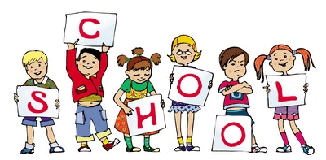

General Reminders
- Please make sure that your child’s P.E kit is in school on a daily basis.
- Miss Gallimore & Miss Hawcroft will be available to speak to every morning on the door and if you require more time an appointment can be made.
- Please label your child’s jumper with their name. If there is no name on a jumper it is almost impossible to find.

Welcome to the Key Stage One newsletter! Thank you to the parents who have emailed your questions. Our enquiry email is ks1parents@pikefold.manchester.sch.uk. We have had a great day celebrating St George’s Day dressed in red, blue and white. The whole school took part in 'Smile Mile' a sponsored 1 mile fun run, in return for a £1 donation. Please keep an eye out on the website for pictures of our fun day.
Polite reminders: if your child has grapes in their pack lunch boxes, can parents please make sure that they are cut in half – from top to bottom so that they are not a choking hazard.
All children should have a PE kit in school.
Year 1 Phonics Screening: Week commencing 12/6/17
SATS Week: Year 2 SATS commence week beginning 22/5/17 – the PowerPoint from the parent SATS meeting is now available on both Year 2 classes website page.

Staff
Miss Hawcroft – KS1 Manager – Deputy Head
1P – Miss Shore, Ms Bowker, Miss Froggart
1F – Miss Hancock, Mrs Stevenson, Miss Burgess
2P – Miss Garner, Mrs Howarth
2F – Miss Trotter, Mrs Thompson, Mrs Robinson
Homework Marks This Week
Spelling Test:
Homework Complete:
Homework this week.
Spellings – Spellings handed out today to be tested on Thursday for Year 1. Year 2 spellings are sent home today to be tested on Wednesday.
Homework – Year 2: Highlighted and dated pages to be completed from the comprehension books and maths workbooks each week. Year 1: complete page 24 of their maths workbook.
Reading – Please make sure that your reading books are returned by Wednesday in order to be changed.
Websites – Check out our new website! Lots of resources and information!
www.pikefold.manchester.sch.uk

Stars of the Week

