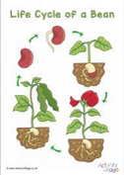
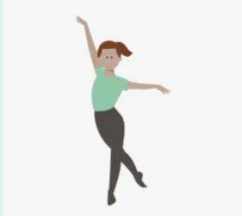

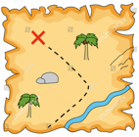
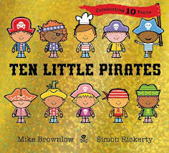
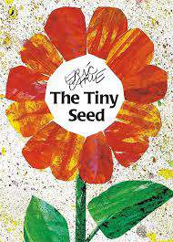
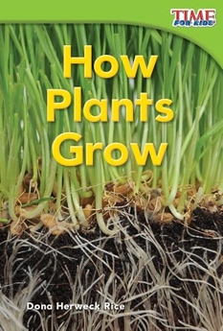

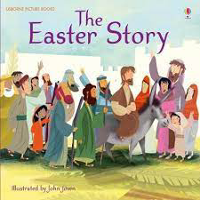
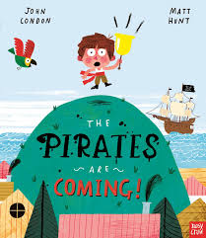
Our Learning Journey, Spring Term 2
Growth- life cycle of a bean. Children will have the opportunity to plant and observe grown of a runner bean and learn about the life cycle of a plant. Children will observe early signs of spring and and compare to the signs off winter.

Maths week 4 and 5- Mass and Shape
Maths week 2 and 3- Partioning 6-9 and Partioning 10,

PE- Body Management
Maths week 1- Complex patterns
During our Pirates topic children will have opportunity to create and label their own maps.
Week 5 – The Easter Story
Week 3 and 4 Spring and Growing
Week 1 and 2- Pirates

