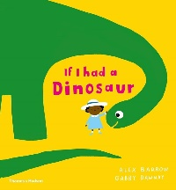
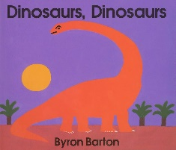

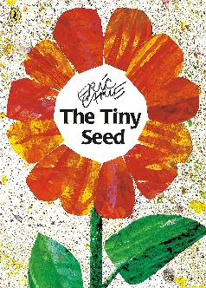
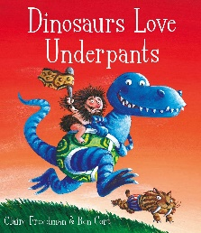
Our Learning Journey, Spring 2
Phonics: This half term we will continue to consolidate Aspect 1-7.

We will also begin to introduce Set 1 sounds using the Read Write Inc scheme. We will focus on one sound per week.

This half term, children will explore exciting topics including Dinosaurs, Spring/Growing, and Easter. They will develop their curiosity about the past by learning about different types of dinosaurs, fossils, and volcanoes through stories, sensory play, and creative activities. As we move into spring, children will observe seasonal changes, plant seeds, and learn about how plants and animals grow. Easter celebrations will provide opportunities for exploring traditions, creating crafts, and engaging in themed activities such as egg hunts and baking. Through these topics, children will develop their communication, social, and early literacy and numeracy skills while engaging in hands-on, play-based learning.
Our Wonderful World – This half term, children will explore celebrations and traditions from different cultures and communities. They will learn about Pancake Day, Mother’s Day, and Easter through stories, role play, creative activities, and hands-on experiences. Children will develop their understanding of the world by engaging in themed activities, such as making pancakes, creating cards and gifts, and learning about springtime changes. They will enhance their communication, social, and fine motor skills through discussions, crafts, and sensory play.
Week 4-5 Jasper’s Beanstalk, Planting a Rainbow
Week 6 We’re going on an Egg Hunt
Key texts we are looking at this term are:
Week 1-3 Dinosaur Roar!, If I had a Dinosaur and The Dinosaur that Pooped a Planet

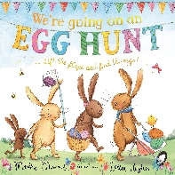
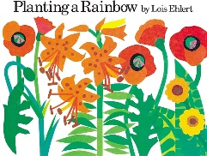
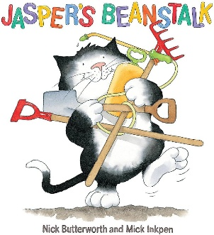
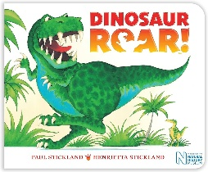
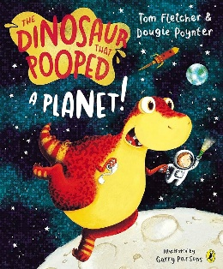
Maths:
Week 1 – Number – Begin to recognise numerals and match to sets.
Week 2 – Measures – Understand and use specific attributes for weight/mass.
Week 3 – Spatial Reasoning – Understand and use language of movement.
Week 4 – Shape – Begin to notice properties of 3D shape and find shapes that are the same.
Week 5 – Sorting and Sequencing – Simple AB sequences varying colour or size.
Topics: Dinosaurs, Spring/Growing, Easter

