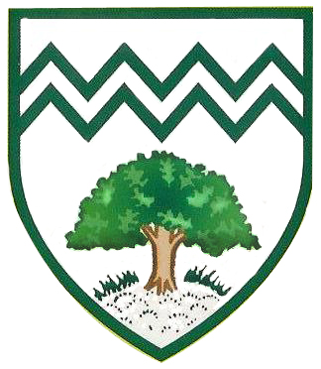

**As readers we will be studying:**

*Queen of the Falls*

*Lost Happy Endings*

As writers we will be learning how to

produce the following text types:

Diary entries

Postcards

Recounts

Traditional tale

We will learn to identify the audience and purpose of writing; organise paragraphs around a theme; use commas after fronted adverbials and use to clarify meaning; describing settings, characters and an alternative ending; expanded noun phrases;dialogue to convert characters;inter grate dialogue using inverted commas

**As Scientists, we will learn about** ‘**Earth and beyond**’. We will learn about the movement of the Sun, Earth and Moon, day and night, seasons and phases of the Moon, geocentric v heliocentric, and our Solar System.

We will also learn about **properties of materials .** We will learn about how to compare and group materials; carry out comparative and fair tests; plan different enquiries. This will have focus liquids, solids and gasses; observing changes overtime.

As Historians, we will learn about the **Mayans**. We will learn who the Maya are, the Maya today, Chichen Itza, Maya society, Pok-a-tok, and why the Maya left their jungle cities.

Silent letters

Suffix ible

Suffix able

Ough letter string

Homophones

Y as a vowel sound

Homophones 2

**As Mathematicians we will learn:**

**Number and Place Value** -Count forwards and backwards in powers of 10, 100, 1000; interpret negative numbers; round numbers up to 1,00,000; Roman Numerals; read, write and compare; order numbers; solve problems involving the above

**Addition and Subtraction –**

Add and subtract whole numbers with more than 4 digits, both mentally and formally; use rounding to check answers; solve multi-step problems .

Plantation Primary School

Curriculum Map

Year 5 Autumn Term

PE

History

As Geographers, we will learn about **‘How Volcanoes Affect the Lives of People on Hiemaey’**. We will learn to recognise and evaluate the interaction of people with physical processes.

As Sportspeople we will learn the skills required in **athletics.** We will learn about **gymnastics** using flexibility, control, strength, balance and technique. We will continue to develop our **swimming** techniques.

French

PSHE

English – Spellings

Art

DT

Music

As Citizens we will learn about families and relationships.

RE

Computing

Geography

Maths

English

As artists we will learn about **Mayan art.** We will study Mayan masks before designing and making our own using a mosaic pattern.

As Designers we will learn about **storybooks**. We will explore lever and linkage systems, plan and design a storybook before making our own and evaluating the process.

As Linguists we will learn to understand, speak, and write French through the topics of **Meet my French family.**

As Musicians we will learn to sing, play, improvise and compose with a focus on **South and West African music** (Harvest).

As Theologises we will learn **‘Stories of Christianity’.** As well as learning more about familiar stories, we will learn about Ruth and Naomi, Daniel, John the Baptist, Paul and The Parables of Jesus.

As **movie makers**, we will be using editing software to create a video production.

We will be completing **E-Safety** lesson to support you if child online.

Science