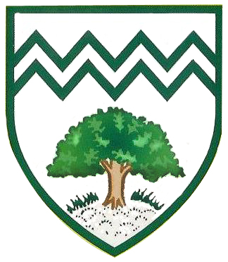

Plantation Primary School

Curriculum Map

Year 2 Summer Term

**As Scientists:**

Our lessons will be very practical and

'hands-on'. We will follow the Snap Science scheme. We will plan and carry out our own investigations, drawing our own conclusions based on the results.

* How can materials change? Exploring the forces of push and pull to change the shape of an object whilst describing their properties further.
* Can you grow healthy plants? Growing different plants and investigating their needs through different experiments.

**As Readers**, we will study:

* *Fantastic Mr Fox* by Roald Dahl
* *Grimm’s Fairytales* (Usborne Books)

**As Writers**, we will be inspired by:

-*The Last Wolf* by Mini Grey

-*Grandad’s Secret Giant* by David Litchfield

**As Spellers**, we will learn new sounds and spelling rules through the RWI Phonics or Spelling Programme.

PE

Art

DT

French

Music

PSHE

As **Citizens**, we will learn about Safety and the Changing Body.

RE

Computing

Geography

History

Maths

English

**As artists**, we will compare and describe a variety of self-portraits. We will then create our own self-portraits using different mediums.

**As designers**, we will design, make, evaluate and most importantly…eat our own perfect pizzas.

**As linguists**, we will listen, speak and read in French, following the three stages of repetition, recognition and recall. We will learn instructions and colours.

**As Musicians**, we will learn about musical structure through the topic **Myths and Legends.** We will also learn about pitch in the topic **Musical Me.**

As **Theologians**, we will learn about Christianity. We will understand what rites of passage means and learn about baptism, Holy Communion and ceremonies for a Christian person.

Learners will begin to understand that sequences of commands have an outcome. They will create their own quiz questions using blocks of codes.

**As Sportspeople**, we will run, jump, throw, send and return through a variety of games and activities. We will also participate in a variety of Outdoor and Adventurous Activities.

**As Geographers**, we will question ‘How does the Geography of Kampong Ayer compare with the Geography of where I live?’

**As Historians**, we will continue to learn about Britain during the First World War. Through examining a range of historical evidence we will explore the question ‘Why was Charles sent to Prison?’

**As Mathematicians**, we will learn:

Addition and Subtraction – TO + TO to 100, TO – TO to 100.

Position and Direction – Patterns and Sequences

Multiplication and Division- Mathematical statements for 2, 5, 10 times tables; commutativity; problem solving.

Fractions – Recogise and find 1/3, ¼, 2/4, ¾ of length, shape and quantity; equivalence of ½ and 2/4; links to time.

Statistics

Solve Problems including Addition and Subtraction – TO + TO; TO – TO

Measurement - Weight

Science